**A game prototype project (source code and a playthough video)**

**The link of source code:**

[Imranhassan1098/Build-2D (github.com)](https://github.com/Imranhassan1098/Build-2D)

The Link of YouTube Playthough video:

<https://youtu.be/XnQ83S3NTbE>

[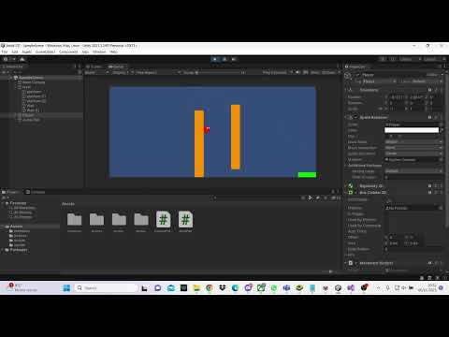](https://youtu.be/XnQ83S3NTbE)